## *INDIAN SCHOOL SOHAR Sultanate of Oman*

## INFORMATICS PRACTICES PROJECT

**Flight Management System**

**Sonali Ajit Karki**

**XII – A**

**G.R.No : 5721**

Acknowledgement

My efforts to complete this project has been possible only due to the kind support and assistance of many individuals, hence I would like to extend my sincere thanks to all of them.

I am highly indebted to my teacher, Mrs. Tanu, for her guidance and constant supervision as well as for providing necessary information regarding the project and also for their support in completing the project.

I would like to thank my group members, Sruthi and Neha, for their kind co-operation in the completion of the project.

I would like to express my special gratitude and thanks to our Principal Mrs. Sanchita Verma for providing the infrastructure and facilities in the school.

I would like to express my gratitude towards my parents and friends for their encouragement which help me in completion of this project.

Content

1. Introduction
2. Feasibility Study
3. System Development Life Cycle
4. System used

* Hardware
* Software

1. Source Code

* Database (Back End)
* User Screen (Front End)

6. Bibliography

Feasibility study

The feasibility study is the important step in any [software development](http://www.exforsys.com/tutorials/programming-concepts/feasibility-study-why-needed-before-programming.html) process. This is because it makes analysis of different aspects like - cost required for developing and executing the system, the time required for each phase of the system and so on. If these important factors are not analyzed then definitely it would have impact on the organization & the development and the system would be a total failure.

The  purpose  of   feasibility study  is  not  to  solve  the  problem, but  to determine  whether   the  problem  is   worth  solving. By making analysis this way it would be possible to make a report of identified area of problem. By making a detailed analysis in this area a detailed document or report is prepared in this phase which has details like project plan or schedule of the project, the cost estimated for developing and executing the system, target dates for each phase of delivery of system developed and so on. This phase is the base of software development process since further steps taken in software development life cycle would be based on the analysis made on this phase and so careful analysis has to be made in this phase.

The feasibility study concentrates on the following area (TELOS) :

* Technology and system feasibility
* Economic feasibility
* Legal feasibility
* Operational feasibility
* Schedule feasibility

# Technology and system feasibility

The assessment is based on an outline design of system requirements, to determine whether the company has the technical expertise to handle completion of the project.

**Economic feasibility (Cost/Benefit Analysis)**

The  economic  feasibility    study  evaluates  the  cost  of  the software  development  against  the  ultimate  income  or  benefits  expected  from  the developed   system. It includes identifying cost and benefit factors like - Development costs and Operating costs. There  must  be  scopes  for  profit  after  the  successful completion  of  the  project.

**Legal feasibility**

It determines whether the proposed system conflicts with legal requirements, e.g. a data processing system must comply with the local Data Protection Acts.

**Operational feasibility**

Operational feasibility is a measure of how well a proposed system solves the problems, and takes advantage of the opportunities identified during scope definition and how it satisfies the requirements identified in the requirements analysis phase of system development.

**Schedule feasibility**

A project will fail if it takes too long to be completed before it is useful. Typically this means estimating how long the system will take to develop, and if it can be completed in a given time period using some methods like payback period. Schedule feasibility is a measure of how reasonable the project timetable is. Given our technical expertise, are the project deadlines reasonable?

**Advantages of making Feasibility study:**

As the initial step of software development life cycle, feasibility study has all the analysis part in it, which helps in analyzing the system requirements completely.

Helps in identifying the risk factors involved in developing and deploying the system

The feasibility study helps in planning for risk analysis

Feasibility study helps in making cost/benefit analysis which helps the organization and system to run efficiently.

Feasibility study helps in making plans for training developers for implementing the system.

So a feasibility study is a report which could be used by the senior or top persons in the organization. This is because based on the report, the organization decides about cost estimation, funding and other important decisions which is very essential for an organization to run profitably and for the system to run stable.

Thus before developing a product or software it is an essential step that one does feasibility study in some or all the areas mentioned which would help in developing and maintaining the software efficiently and effectively within budgeted costs

Software Development Life Cycle

The Systems Development Life Cycle (SDLC) is a conceptual model used in project management that describes the stages involved in an information system development project from an initial feasibility study through maintenance of the completed application.

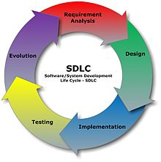The following are the activities of the SDLC

* Software requirement analysis
* Systems analysis and design
* Design/Code generation
* Testing
* Development and Maintenance

A Systems Development Life Cycle (SDLC) adheres to important phases that are essential for developers, such as [planning](http://en.wikipedia.org/wiki/Planning), [analysis](http://en.wikipedia.org/wiki/Analysis), [design](http://en.wikipedia.org/wiki/Design), and [implementation](http://en.wikipedia.org/wiki/Implementation). A number of system development life cycle (SDLC) models have been created such as waterfall, fountain, spiral etc.

**Requirement Analysis/Investigation**

The 1st stage of SDLC is the investigation phase. During this stage, business opportunities and problems are identified, and information technology solutions are discussed. Multiple alternative projects may be suggested and their feasibility analyzed. The results of the feasibility study can then be compiled into a report, along with preliminary specifications. When the investigation stage ends, a decision whether or not to move forward with the project should be made.

**System Analysis**

The goal of [system analysis](http://en.wikipedia.org/wiki/Systems_analysis) is to determine where the problem is, in an attempt to fix the system. It analyzes the requirement for the proposed system. To understand the nature of the program to build, the system engineer must understand the information domain for the software, as well as required functions, performance and the interfacing. This step involves [breaking down](http://en.wikipedia.org/wiki/Work_breakdown_structure) the system in different pieces to analyze the situation, analyzing project goals, breaking down what needs to be created. From the available information the system engineer develops a list of system level requirement for the project.

**Design**

Systems design describes screen layouts, business rules, process diagrams, a complete entity-relationship diagram with a full data dictionary and other documentation. It defines specifically how the software is to be written including an object model, the client/server technology, a detailed database design etc. These design elements are intended to describe the software in sufficient detail that skilled programmers may develop the software with minimal additional input design. Analysis and design are very important in the whole development cycle. Any glitch in the design could be very expensive to solve in the later stage of the software development. The design must be translated into a machine readable form.

**Testing**

In this stage, all the pieces of software are brought together into a special testing environment and then are checked for errors, bugs and interoperability. Unit, system and user acceptance testing is often performed.

**Deployment and Maintenance**

Deployment is the final stage of initial development. It involves installation, initial training and may involve hardware and network upgrades. Software will definitely undergo change once it is delivered to the customer. There may be many reasons for the change. Change could be due to some unexpected input values into the system. The software should be developed to accommodate changes that could take place during the post implementation period. Maintaining the system is also an important aspect of SDLC. What happens during the rest of the software's life: changes, correction, additions, change to a different computing platform and more. Maintenance is often the longest of all the stages.

Introduction

The project flight management system can be used to handle transactions in a flight travel agency

Java is used as the front end of the proj while MySQL as the backend. The application can perform the basic operations needed in a travel agency such as addition of flight details and passengers details along with their flight details. The application takes the details of passengers with their flight itinerary as an input and this helps generate specific reports of flight travels on particular dates.

The application has been programmed such the it takes minimum input from the user and gives maximum output. Tooltips , keyboard shortcuts , visual feedback , use of conventional icons and words makes the program user friendly. The front end also provides a facility to authenticate users by providing a login screen.

The application consists of 4 modules :

1. A login frame which ensures only authorized personnel are allowed access.
2. The flight frame through which flight details can be entered.
3. The passeneger frame through which passengers details with their flight itinerary can be entered.
4. A report frame which generates report.

System Used

**HARDWARE:**

* Samsung , intel Core i5 processors with Windows 8 Operating System

**SOFTWARE**

* Netbeans IDE 8.1

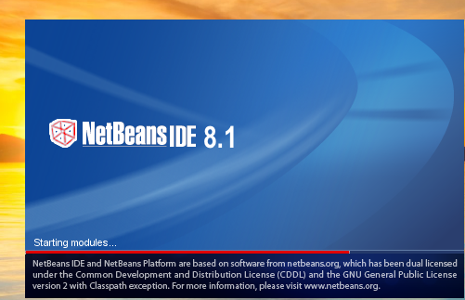

* MySQL



Database (Back End)

1. Table Name : ftbl (contains flight details)

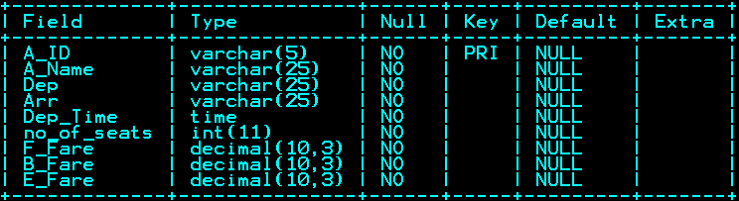

**CREATE TABLE COMMMAND:**

Create table ftbl ( A_ID varchar(5) Primary Key , A_Name varchar(25) , Dep varchar(25) , Arr varchar(25) , Dep_Time time , no_of_seats int , F_Fare decimal(10,3) , B_Fare decimal(10,3) , E_Fare decimal(10,3) );

2. Table Name : ptbl (contains passenger details)

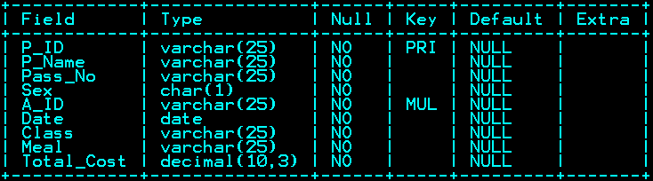

**CREATE TABLE COMMMAND:**

Create table ptbl ( P_ID varchar(5) Primary Key , P_Name varchar(25) , Pass_Np varchar(25) , Sex char(1) , A_ID varchar(25) , Date date , Class varchar(25) , Meal varchar(25) , Total_Cost decimal(10,3) );

Login Screen

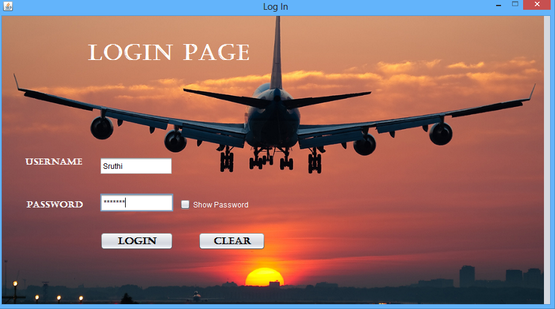

|  |  |  |
| --- | --- | --- |
| **Control** | | **Control Name** |
| Username (Text Field) | uname | |
| Password (Text Field) | pass | |
| Login (Button) | login | |
| Clear (Button) | clear | |
| Show Password (Check Box) | show | |

**//import Statement**

import javax.swing.JOptionPane;

**//When logging in**

String u = uname.getText();

String p = new String(pass.getPassword());

if(u.equalsIgnoreCase("Sruthi") && p.equals("noitpecni") || u.equalsIgnoreCase("Sonali") && p.equals("setarip") || u.equalsIgnoreCase("Neha") && p.equals("winchester") ){

new MainF().setVisible(true);

this.dispose();

}

else

JOptionPane.showMessageDialog(this, " Incorrect Username or Password");

**// show password chckbox is selected**

showActionPerformed{

String p = new String(pass.getPassword());

if(show.isSelected())

pass.setEchoChar((char)0);

}

**//code to clear the entered values**

clearActionPerformed{

uname.setText("");

pass.setText("");

show.setSelected(false);

}

Main Frame

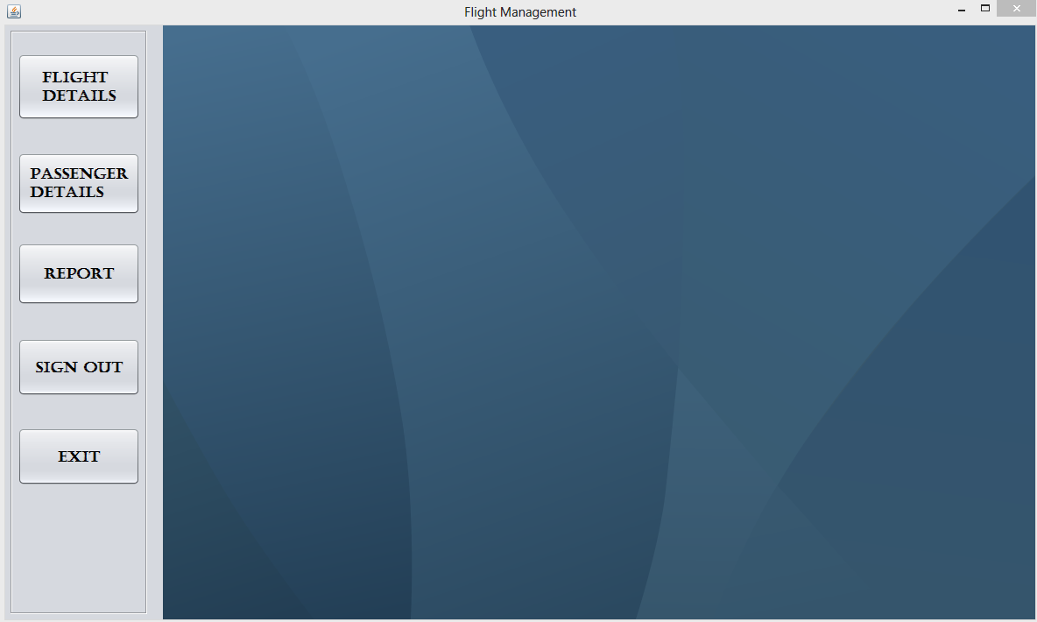

|  |  |  |
| --- | --- | --- |
| **Control** | | **Control Name** |
| Flight Details (Button) | fdetails | |
| Passenger Details (Button) | pdetails | |
| Report (Button) | report | |
| Sign Out (Button) | sout | |
| Exit (Button) | exit | |

**//flight details button is clicked**

fdetailsActionPerformed{

Fnew fd=new Fnew();

sp.add(fd);

fd.setVisible(true);

}

**//passenger details button is clicked**

pdetailsActionPerformed{

Pass ps=new Pass();

sp.add(ps);

ps.setVisible(true);

}

**//report button is clicked**

reportActionPerformed{

Report rp=new Report();

sp.add(rp);

rp.setVisible(true);

}

**//sign out button is clicked**

soutActionPerformed{

new Login().setVisible(true);

this.dispose();

}

**//exit button is clicked**

exitActionPerformed{

System.exit(0);

}

FLIGHT FRAME

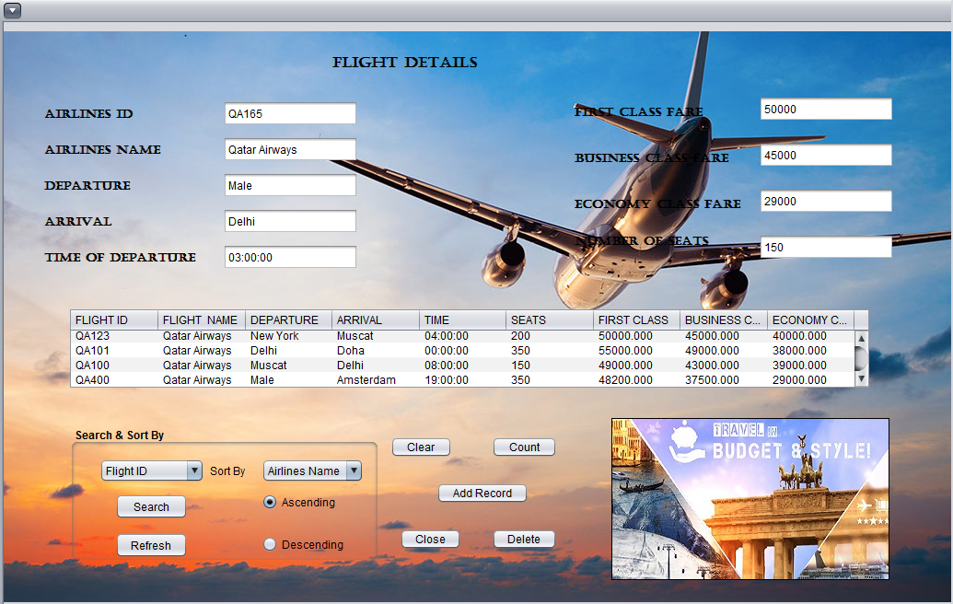

|  |  |
| --- | --- |
| **Control** | **Control Name** |
| Flight Table (Table) | airtbl |
| Airlines ID (Text Field) | aid |
| Airlines Name (Text Field) | aname |
| Departure (Text Field) | dep |
| Arrival (Text Field) | arr |
| Time of Departure (Text Field) | tdept |
| First Class Fare (Text Field) | ffare |
| Business Class Fare (Text Field) | bfare |

|  |  |
| --- | --- |
| Economy Class Fare (Text Field) | efare |
| Number of Seats (Text Field) | seats |
| Search (Combo Box) | searchcombo |
| Sort By (Combo Box) | sortcombo |
| Search (Button) | search |
| Refresh (Button) | refresh |
| Ascending (Radio Button) | asc |
| Descending (Radio Button) | desc |
| Clear (Button) | clear |
| Count (Button) | cnt |
| Add Record (Button) | add |
| Close (Button) | close |
| Delete (Button) | delete |
| Refresh (Button) | refresh |

**//import statements**

import java.sql.*;

import javax.swing.JOptionPane;

import javax.swing.table.DefaultTableModel;

**//global variables**

Connection con;

String sr="";

**//method definitions**

void opencon(){

try{

Class.forName("java.sql.Driver");

con=DriverManager.getConnection("jdbc:mysql://localhost/fm","root",null);

}catch(Exception e){

JOptionPane.showMessageDialog(this,e.getMessage());

}

}

void display() {

try{

String q="Select * from ftbl ";

String s=(String)searchcombo.getSelectedItem();

if(s.equalsIgnoreCase("flight id")){

q+="where A_ID like '%"+sr+"%'";

}

else if(s.equalsIgnoreCase("flight name")){

q+="where A_Name like '%"+sr+"%'";

}

else if(s.equalsIgnoreCase("departure")){

q+="where dep like '%"+sr+"%'";

}

else if(s.equalsIgnoreCase("arrival")){

q+="where arr like '%"+sr+"%'";

}

String srt=(String) sortcombo.getSelectedItem();

if(srt.equalsIgnoreCase("Airlines Name") && asc.isSelected())

q+=" order by A_Name";

else if(srt.equalsIgnoreCase("Airlines Name") && desc.isSelected())

q+=" order by A_Name desc";

if(srt.equalsIgnoreCase("Airlines ID") && asc.isSelected())

q+=" order by A_ID";

else if(srt.equalsIgnoreCase("Airlines ID") && desc.isSelected())

q+=" order by A_ID desc";

if(srt.equalsIgnoreCase("Time") && asc.isSelected())

q+=" order by dep_time";

else if(srt.equalsIgnoreCase("Time") && desc.isSelected())

q+=" order by dep_time desc";

Statement st=con.createStatement();

ResultSet rs=st.executeQuery(q);

DefaultTableModel dtm=(DefaultTableModel)airtbl.getModel();

String ai,an,dep,ar,tdep,ff,bf,ef,n;

while(dtm.getRowCount()>0)

dtm.removeRow(0);

while(rs.next()){

ai=rs.getString(1);

an=rs.getString(2);

dep = rs.getString(3);

ar = rs.getString(4);

tdep = rs.getString(5);

n = rs.getString(6);

ff = rs.getString(7);

bf = rs.getString(8);

ef = rs.getString(9);

Object nr[]={ai,an,dep,ar,tdep,n,ff,bf,ef};

dtm.addRow(nr);

}

sr="";

if(dtm.getRowCount()==0)

JOptionPane.showMessageDialog(this,"No Matching Records Found");

}catch(Exception e){

JOptionPane.showMessageDialog(this,e.getMessage());

}

}

**//when internal frame is opened**

**//formInternalFrameOpened**

opencon();

display();

**//code to add record into the flight table**

**//addActionPerformed**

try{

String ai = aid.getText();

String an = aname.getText();

String dep = dept.getText();

String ar = arr.getText();

String n = seats.getText();

String tdep = tdept.getText();

String bf = bfare.getText();

String ff = ffare.getText();

String ef = efare.getText();

String q = "Insert into ftbl values('"+ai+"','"+an+"','"+dep+"','"+ar+"','"+tdep+"',"+n+","+ff+","+bf+","+ef+")";

Statement st = con.createStatement();

st.executeUpdate(q);

display();

JOptionPane.showMessageDialog(this, " Record has been added successfully")

}catch(Exception e){

JOptionPane.showMessageDialog(this, e.getMessage());

}

**//code to count the number of records in the flight table**

**//cntActionPerformed**

try{

String q = "Select count(*) from ftbl";

Statement st = con.createStatement();

ResultSet rs = st.executeQuery(q);

int c = 0;

if(rs.next())

c= rs.getInt(1);

JOptionPane.showMessageDialog(this," NUMBER OF RECORDS =" + c);

}catch(Exception e){

JOptionPane.showMessageDialog(this, e.getMessage());

}

**//code to clear the entered values**

**//clearActionPerformed**

aid.setText("");

aname.setText("");

dept.setText("");

arr.setText("");

seats.setText("");

tdept.setText("");

bfare.setText("");

ffare.setText("");

efare.setText("");

**//code to delete records from the flight table**

**//deleteActionPerformed**

try{

String a=JOptionPane.showInputDialog("Enter Flight ID to be deleted.");

String q="Delete from ftbl where A_ID='"+a+"'";

Statement st=(Statement)con.createStatement();

st.executeUpdate(q);

display();

JOptionPane.showMessageDialog(this,"The record has been successfully deleted.");

}catch(Exception e){

JOptionPane.showMessageDialog(this, e.getMessage());

}

**//code for refresh button**

**//refreshActionPerformed**

sortcombo.setSelectedItem("Airlines Name");

searchcombo.setSelectedItem("Flight");

asc.setSelected(true);

display();

**//search and sort by codes**

**//searchActionPerformed**

try{

String s=(String)searchcombo.getSelectedItem();

if(s.equalsIgnoreCase("flight id"))

sr=JOptionPane.showInputDialog(" Enter Flight ID");

else if(s.equalsIgnoreCase("flight name"))

sr=JOptionPane.showInputDialog(" Enter Airlines Name");

else if(s.equalsIgnoreCase("departure"))

sr=JOptionPane.showInputDialog(" Enter Departure");

else if(s.equalsIgnoreCase("arrival"))

sr=JOptionPane.showInputDialog("Arrival");

display();

}catch(Exception e){

JOptionPane.showMessageDialog(this, e.getMessage());

}

**//sortcomboActionPerformed**

display();

**//to display the records in ascending order of selected column**

**//ascActionPerformed**

display();

**//to display the records in descending order of selected column**

**//descActionPerformed**

display();

**//to exit the flight frame**

**//closeActionPerformed**

this.dispose();

Passenger Frame

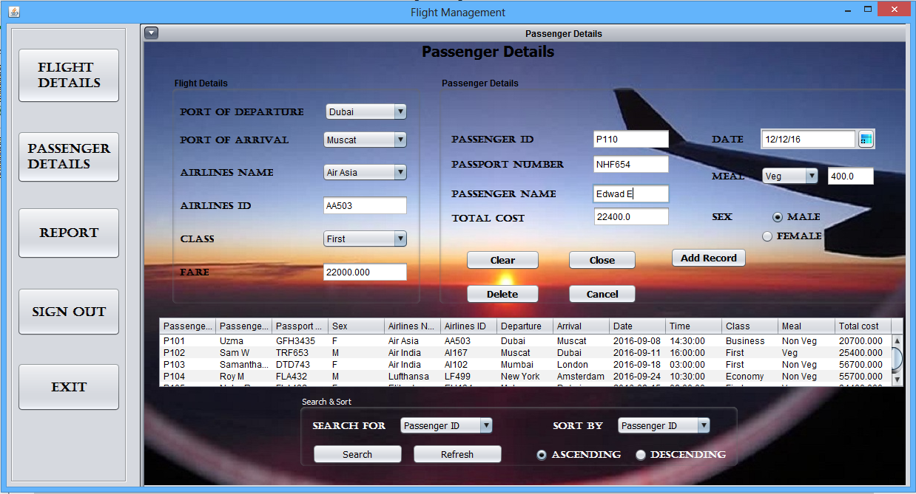

|  |  |
| --- | --- |
| **Control** | **Control Name** |
| Port Of departure (combo box) | dep |
| Port Of Arrival (combo box) | arrival |
| Airlines Name (combo box) | aname |
| Airlines ID (text field) | aid |
| Class (combo box) | fclass |
| Fare(label) | fare |
| Time Of Departure(text field) | time |
| Passenger ID(text field) | pid |
| Passport Number(text field) | pno |
| Passenger Name(text field) | pname |
| Total Cost(label) | tcost |
| Date(date chooser) | depdate1 |
| Meal(label) | mealcost |
| Meal(combo box) | meal |
| Male(radio button) | m |
| Female(radio button) | f |
| Clear(button) | clear |
| Close(button) | close |
| Delete(button) | del |
| Add Record(button) | addrec |
| Cancel(button) | cancel |
| Passenger table(table) | ptable |
| Search (combo box) | searchcombo |
| Search(button) | search |
| Refresh(button) | refresh |
| Sort (combo box) | sortcombo |
| Ascending(radio button) | asc |
| Descending(radio button) | desc |

**//import statements**

import java.sql.*;

import java.sql.Statement;

import javax.swing.JOptionPane;

import javax.swing.table.DefaultTableModel;

**//global variables**

Connection con;

String sr="";

String dept ="";

String ar ="";

String an ="";

String id = "";

String cl = "";

double c=0;

double t =0;

String ml = "";

double tc;

**//method declaration**

void getFare(String id, String cls){

try{

String fr="";

if(cls.equalsIgnoreCase("first"))

fr="F_fare";

else if(cls.equalsIgnoreCase("business"))

fr="b_fare";

else if(cls.equalsIgnoreCase("economy"))

fr="e_fare";

String q = "select "+fr+" from ftbl where a_id='"+id+"'";

Statement st = con.createStatement();

ResultSet rs = st.executeQuery(q);

String a = "";

while(rs.next()){

a=rs.getString(1);

fare.setText(a);

t = Double.parseDouble(a);

}

tcost.setText(t+c+"");

}catch(Exception e){

JOptionPane.showMessageDialog(this, e.getMessage());

}

}

void opencon(){

try{

Class.forName("java.sql.Driver");

con=DriverManager.getConnection("jdbc:mysql://localhost/fm","root",null);

}catch(Exception e){

JOptionPane.showMessageDialog(this, e.getMessage());

}

}

void display(){

try{

String q = "Select * from ftbl natural join ptbl";

String s=(String)searchcombo.getSelectedItem();

if(sr.length()>0){

if(s.equalsIgnoreCase("Passenger id"))

q+="where P_ID like '%"+sr+"%'";

else if(s.equalsIgnoreCase("passenger name"))

q+="where P_Name like '%"+sr+"%'";

else if(s.equalsIgnoreCase("departure"))

sr=JOptionPane.showInputDialog("Departure");

else if(s.equalsIgnoreCase("arrival"))

sr=JOptionPane.showInputDialog("Arrival");

}

String srt=(String) sortcombo.getSelectedItem();

if(srt.equalsIgnoreCase("passenger id") && asc.isSelected())

q+=" order by p_id";

else if(srt.equalsIgnoreCase("passenger id") && desc.isSelected())

q+=" order by p_id desc";

if(srt.equalsIgnoreCase("passenger name") && asc.isSelected())

q+=" order by p_name";

else if(srt.equalsIgnoreCase("passenger name") && desc.isSelected())

q+=" order by p_name desc";

if(srt.equalsIgnoreCase("date") && asc.isSelected())

q+=" order by date";

else if(srt.equalsIgnoreCase("date") && desc.isSelected())

q+=" order by date desc";

Statement st = con.createStatement();

ResultSet rs = st.executeQuery(q);

DefaultTableModel dtm = (DefaultTableModel) ptable.getModel();

String d,a,an,ai,t,pi,p,pn,dt,c,f,m,tc;

while(dtm.getRowCount()>0)

dtm.removeRow(0);

while(rs.next()){

pi = rs.getString("p_id");

pn = rs.getString("p_name");

p = rs.getString("pass_no");

s = rs.getString("sex");

an = rs.getString("A_NAME");

ai = rs.getString("A_ID");

d = rs.getString("dep");

a = rs.getString("arr");

dt = rs.getString("date");

t = rs.getString("dep_time");

c = rs.getString("class");

m = rs.getString("meal");

tc = rs.getString("total_cost");

Object nr[] = {pi,pn,p,s,an,ai,d,a,dt,t,c,m,tc};

dtm.addRow(nr);

}

}catch(Exception e){

JOptionPane.showMessageDialog(this, e.getMessage());

}

**//adding a record**

addrecActionPerformed {

try{

String ai = aid.getText();

String s = null;

if(m.isSelected())

s = "M";

else if(f.isSelected())

s = "F";

String pi = pid.getText();

String p = pno.getText();

String pn = pname.getText();

String dt = depdate1.getText();

String c1 = (String) fclass.getSelectedItem();

String m1 = (String) meal.getSelectedItem();

String ti = (String) time.getText();

String tc1 = tcost.getText();

String q = "Insert into ptbl values('"+pi+"','"+pn+"','"+p+"','"+s+"','"+ai+"','"+dt+"','"+c1+"','"+m1+"',"+tc1+")";

Statement st = con.createStatement();

st.executeUpdate(q);

JOptionPane.showMessageDialog(this,"The record has been successfully added.");

display();

}catch(Exception e){

JOptionPane.showMessageDialog(this, e.getMessage());

}

}

**//when the frame is opened**

formInternalFrameOpened {

opencon();

display();

meal.setSelectedItem("Veg");

try{

String q = "select distinct dep from ftbl";

Statement st = con.createStatement();

ResultSet rs = st.executeQuery(q);

String a="";

while(rs.next()){

a=rs.getString(1);

dep.addItem(a);

}

cl = (String) fclass.getSelectedItem();

id=aid.getText();

getFare(id, cl);

}catch(Exception e){

JOptionPane.showMessageDialog(this, e.getMessage());

}

}

**//deleting records**

delActionPerformed {

try{

String j = JOptionPane.showInputDialog("Enter Passenger ID to be delted");

String q = "Delete from ptbl where P_ID='"+j+"'";

Statement st = con.createStatement();

st.executeUpdate(q);

display();

}catch(Exception e){

JOptionPane.showMessageDialog(this, e.getMessage());

}

}

**//selection of arrival port**

depActionPerformed {

try{

arrival.removeAllItems();

aname.removeAllItems();

dept = (String)dep.getSelectedItem();

String q = "select distinct arr from ftbl where dep = '"+dept+"'";

Statement st = con.createStatement();

ResultSet rs = st.executeQuery(q);

while(rs.next()){

arrival.addItem(rs.getString(1));

}

getFare(id, cl);

}catch(Exception e){

JOptionPane.showMessageDialog(this, e.getMessage());

}

}

anameActionPerformed {

try{

if(aname.getSelectedIndex()>=0){

dept = (String) dep.getSelectedItem();

ar = (String) arrival.getSelectedItem();

an = (String) aname.getSelectedItem();

fclass.setSelectedItem("First");

String q = "select a_id,dep_time from ftbl where dep = '"+dept+"' and arr='"+ar+"' and a_name = '"+an+"'";

Statement st = con.createStatement();

ResultSet rs = st.executeQuery(q);

while(rs.next()){

aid.setText(rs.getString(1));

time.setText(rs.getString(2));

}

cl = (String) fclass.getSelectedItem();

id=aid.getText();

getFare(id,cl);

}

}catch(Exception e){

JOptionPane.showMessageDialog(this, e.getMessage());

}

}

**//for searching records**

searchActionPerformed{

try{

String sr1="";

String s1=(String)searchcombo.getSelectedItem();

if(s1.equalsIgnoreCase("passenger id"))

sr1=JOptionPane.showInputDialog("Passenger ID");

else if(s1.equalsIgnoreCase("flight name"))

sr1=JOptionPane.showInputDialog("Airlines");

else if(s1.equalsIgnoreCase("departure"))

sr1=JOptionPane.showInputDialog("Departure");

else if(s1.equalsIgnoreCase("arrival"))

sr1=JOptionPane.showInputDialog("Arrival");

display();

}catch(Exception e){

JOptionPane.showMessageDialog(this, e.getMessage());

}

}

**//for sorting the records**

sortcomboActionPerformed{

display();

}

**//selection of airlines name**

arrivalActionPerformed {

try{

if(dep.getSelectedIndex()>=0){

aname.removeAllItems();

dept=(String)dep.getSelectedItem();

ar=(String)arrival.getSelectedItem();

String q = "select distinct a_name from ftbl where dep = '"+dept+"' and arr='"+ar+"'";

Statement st = con.createStatement();

ResultSet rs = st.executeQuery(q);

while(rs.next()){

aname.addItem(rs.getString(1));

}

}

}catch(Exception e){

JOptionPane.showMessageDialog(this , e.getMessage());

}

}

fclassActionPerformed{

cl = (String) fclass.getSelectedItem();

id=aid.getText();

getFare(id,cl);

}

**//to display time**

timeActionPerformed {

try{

String ai = aid.getText();

String q = "select dep_time from ftbl where a_id='"+ai+"'";

Statement st = con.createStatement();

ResultSet rs = st.executeQuery(q);

while(rs.next()){

time.setText(rs.getString(1));

}

}catch(Exception e){

JOptionPane.showMessageDialog(this, e.getMessage());

}

mealActionPerformed{

ml = (String)meal.getSelectedItem();

if(ml.equalsIgnoreCase("non veg"))

c = 700;

else if(ml.equalsIgnoreCase("veg"))

c = 400;

mealcost.setText(""+c);

tcost.setText(t+c+"");

}

**//code to clear the entered values**

clearActionPerformed {

pid.setText("");

pname.setText("");

pno.setText("");

m.setSelected(true);

meal.setSelectedItem("Veg");

tcost.setText("");

try{

dep.removeAllItems();

String q = "select distinct dep from ftbl";

Statement st = con.createStatement();

ResultSet rs = st.executeQuery(q);

while(rs.next()){

dep.addItem(rs.getString(1));

}

}catch(Exception e){

JOptionPane.showMessageDialog(this, e.getMessage());

}

**//code to exit passenger frame**

closeActionPerformed{

this.dispose();

}

Report Frame

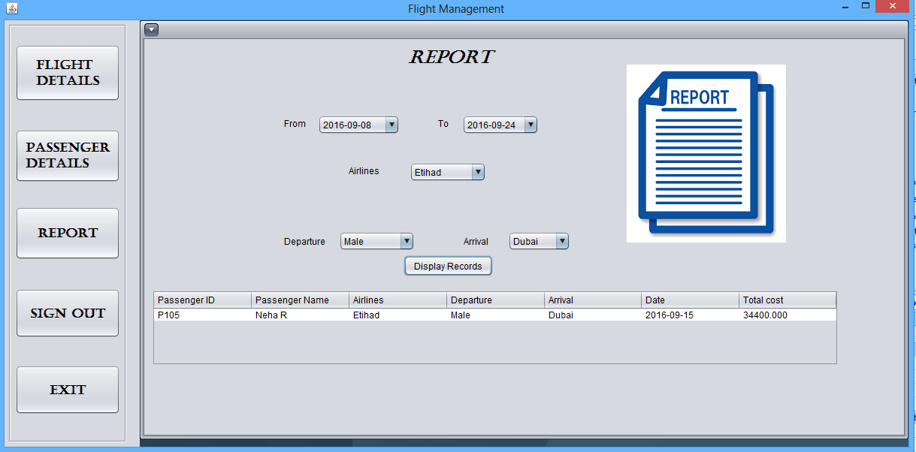

|  |  |
| --- | --- |
| **Control** | **Control Name** |
| From (Combo Box) | from |
| To (Combo Box) | to |
| Airlines (Combo Box) | aname |
| Departure (Combo Box) | dep |
| Arrival (Combo Box) | arr |

**//import statement**

import java.sql.*;

import java.sql.Statement ;

import javax.swing.JOptionPane;

import javax.swing.table.DefaultTableModel;

**//method definition and public variables**

Connection con;

String an,dp,ar;

**void opencon(){**

try{

Class.forName("java.sql.Driver");

con=DriverManager.getConnection("jdbc:mysql://localhost/fm","root",null);

}catch(Exception e){

JOptionPane.showMessageDialog(this, e.getMessage());

}

}

**void display(){**

try{

an = (String) aname.getSelectedItem();

ar = (String) arr.getSelectedItem();

dp = (String) dep.getSelectedItem();

String fr = (String) from.getSelectedItem();

String t = (String) to.getSelectedItem();

// if fr or t is all then what will the query be

String q = "Select * from ptbl natural join ftbl ";

String r = "";

String s = " where ";

String date = " date between '" +fr + "' and '"+t+"'";

if(!an.equals("All"))

r+=" a_name = '"+an+"'";

if(!dp.equals("All")){

if(r.length()>1)

r+=" and";

r+=" dep = '"+dp+"'";

}

if(!ar.equals("All")){

if(r.length()>1)

r+=" and";

r+=" arr = '"+ar+"'";

}

if(fr.equals("All") && !t.equals("All")){

if(r.length()>1)

r+=" and";

r+=" date <= '"+ t+"'";

}

if(t.equals("All") && !fr.equals("All")){

if(r.length()>1)

r+=" and";

r+=" date >= '"+ fr+"'";

}

if(!t.equals("All") && !fr.equals("All")){

if(r.length()>1)

r+=" and";

r+=date;

}

if(t.equals("All") && fr.equals("All")){

if(r.length()>1)

q+= s + r;

}

else if(r.length()>0)

q+= s + r ;

Statement st = con.createStatement();

ResultSet rs = st.executeQuery(q);

DefaultTableModel dtm = (DefaultTableModel)reporttbl.getModel();

String d,a,an1,pi,pn,dt,tc;

while(dtm.getRowCount()>0)

dtm.removeRow(0);

while(rs.next()){

pi = rs.getString("P_ID");

pn = rs.getString("P_Name");

an1 = rs.getString("A_NAME");

d = rs.getString("Dep");

a = rs.getString("Arr");

dt = rs.getString("Date");

tc = rs.getString("Total_Cost");

Object nr[] = {pi,pn,an1,d,a,dt,tc};

dtm.addRow(nr);

}

}catch(Exception e){

JOptionPane.showMessageDialog(this, e.getMessage());

}

}

**//when internal frame is opened**

formInternalFrameOpened{

opencon();

try{

from.removeAllItems();

String q = "select distinct date from ftbl natural join ptbl order by date asc";

Statement st = con.createStatement();

ResultSet rs = st.executeQuery(q);

while(rs.next()){

from.addItem(rs.getString(1));

}

}catch(Exception e){

JOptionPane.showMessageDialog(this, e.getMessage());

}

}

**//selection of date(from)**

fromActionPerformed{

try{

to.removeAllItems();

String q = "select distinct date from ftbl natural join ptbl order by date asc";

Statement st = con.createStatement();

ResultSet rs = st.executeQuery(q);

while(rs.next()){

to.addItem(rs.getString(1));

}

}catch(Exception e){

JOptionPane.showMessageDialog(this, e.getMessage());

}

}

**//selection of date(to)**

toActionPerformed{

try{

aname.removeAllItems();

aname.addItem("All");

String q = "select distinct a_name from ftbl ";

Statement st = con.createStatement();

ResultSet rs = st.executeQuery(q);

while(rs.next()){

aname.addItem(rs.getString(1));

}

}catch(Exception e){

JOptionPane.showMessageDialog(this, e.getMessage());

}

}

**// selection of airline name**

anameActionPerformed{

try{

dep.removeAllItems();

dep.addItem("All");

String an = (String) aname.getSelectedItem();

String q = "select distinct dep from ftbl natural join ptbl where a_name = '"+an+"'";

Statement st = con.createStatement();

ResultSet rs = st.executeQuery(q);

while(rs.next()){

dep.addItem(rs.getString(1));

}

}catch(Exception e){

JOptionPane.showMessageDialog(this, e.getMessage());

}

}

**//selection of departure location**

depActionPerformed{

try{

arr.removeAllItems();

arr.addItem("All");

an = (String) aname.getSelectedItem();

dp = (String) dep.getSelectedItem();

String q = "select distinct arr from ftbl where a_name = '"+an+"' and dep = '"+dp+"'";

Statement st = con.createStatement();

ResultSet rs = st.executeQuery(q);

while(rs.next()){

arr.addItem(rs.getString(1));

}

}catch(Exception e){

JOptionPane.showMessageDialog(this, e.getMessage());

}

}

**//display record button is clicked**

recActionPerformed{

display();

}

Bibliography

[www.netbeans.org](http://www.netbeans.org)

[www.youtube.com](http://www.youtube.com)

[www.google.com](http://www.google.com)

Informatics Practics class 12 Textbook